**Fourth iteration report**

**Group 6:**

1. Ragunandan Rao Malangully – 45
2. Sandeep Siddhi – 57
3. Raviteja Reddy Kandakatla – 33
4. Pradeep Chaitanya Tirumalsetty - 61

Submitted on 12/08/2015

**Introduction:**

This document intends to provide an overall description of the project named “Travel Guide” in detail. The project schedule and the plan of action is also discussed. The proposal document submitted would give an insight about what the project is about. The main outcome of the second increment is the three modules of the application (weather, places of interest and language convertor modules). As of current state we have not deviated from our initial proposal that we submitted earlier.

**Project goal and objectives:**

**Overall goal**

The project goal is to put together a set of related and useful web services under one umbrella. The app intends to serve the needs of a person who is in search for some trivial information about a place that he in planning or intends to travel to. The significance of the application lies in the fact that it serves as a one stop shop to interact with various information sources. Additionally the app lets users to interact with social media. The objectives of the application are as follows.

**Objectives**

* To reduce the user time in searching for information across various sources.
* To develop a system architecture that can integrate the different features that the system proposes.
* To ensure that each iteration is tested thoroughly before heading to the next one.
* To develop a user friendly application.
* To provide user a tool to keep track of items that are required for the travel and the duration of the stay.
* Ensure that the user never misses important information in a touring country by providing the translate feature that translates the text into the user specified language.
* The user would never miss out on famous tourist locations as our app has a feature to suggest famous tourist attractions or hangout spots in a place.
* A tourist never feels away from home. The accommodation finder is a tool that helps the user in selecting his home away from home.
* Currency conversion is one of the major problems that tourists face when visiting other countries. The users of this app have no such worries as we take of currency conversions based on the latest foreign exchange rates.
* The user can prepare for the weather of the place he is visiting. The system predicts the latest weather information of the place of interest.

**Fourth Increment Report**

This document is a report of fourth iteration of work performed on the Travel Guide Mobile App. The document emphasizes on the details of the app and the progress of the work done so far in developing the app. This document intends to provide an overall description of the project named “Travel Guide” in detail.

The outcome of the fourth increment is UI changes in each and every module of the project. To give a better look and feel to the app, we have used better icons to display on the home screen.

Also we have added image analysis for registration using alchemy API which captures the image and performs analysis to determine if registered user is a robot or a human.

On the accommodation and place of interest modules, we have customized the map icons to give a better understanding of the icons.

To avoid button, we have modified the code so that the action performs on the click of icon.

We have created a video describing our project and uploaded it to YouTube.

**Project Demo URL**

<https://www.youtube.com/watch?v=BD-_Lyk1jko>

**Bluemix URLs:**

<http://travelguideservices.mybluemix.net/userServices>

<http://travelguideservices.mybluemix.net/userTaskService>

**Project Management Site Link:**

We have used the Visual Studio Online as our Project Management tool and it can be accessed using the below link.

<https://aseprojectgroup6.visualstudio.com/DefaultCollection/TravelGuide/dashboards>

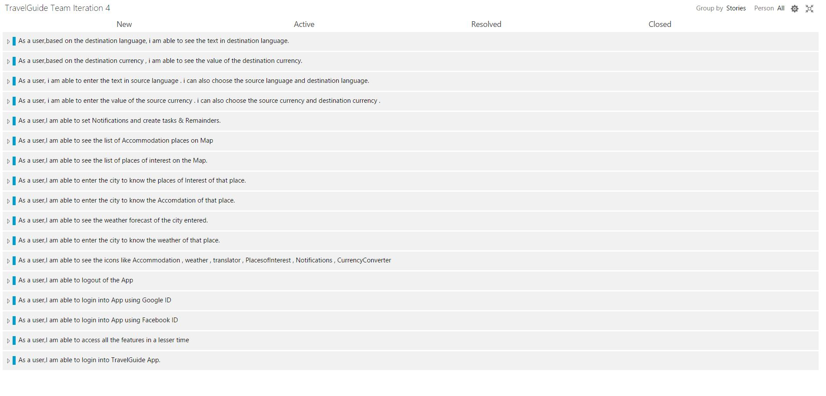

**Screen shots**

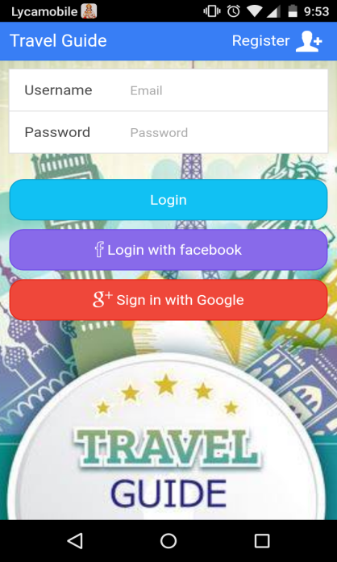

This is Login page where a user will enter his creditials to enter into the App.

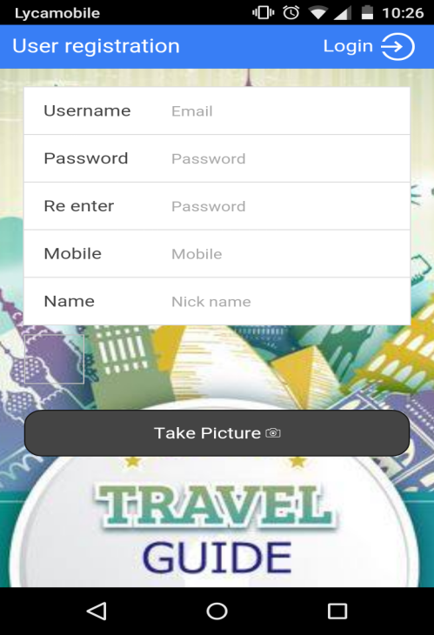

This is Registration page where a user can enter his details and register to the APP.in this page the user can enter his credentials and take a picture and get registered.

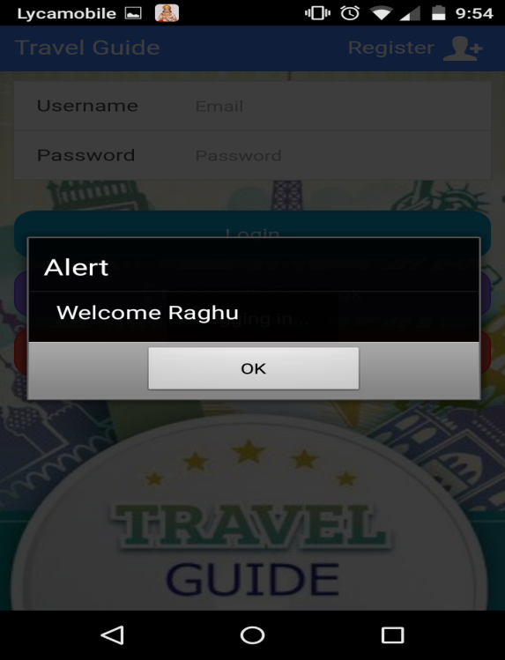

This alert box will come after the user will successfully log in to the App.

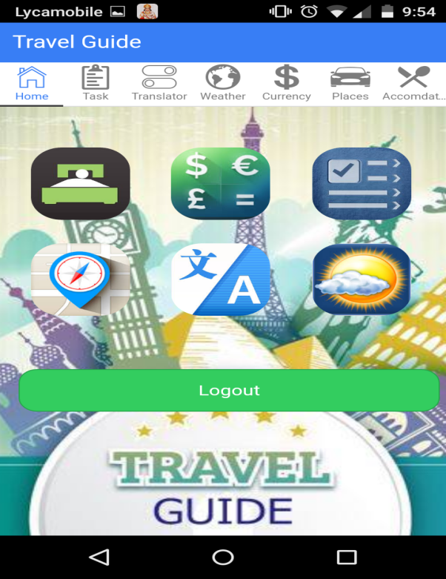

This is Home page of the App.in this page we can see the icons like Language Translator, Currency Converter, Accommodation, places Of Interest, Weather and Notifications.

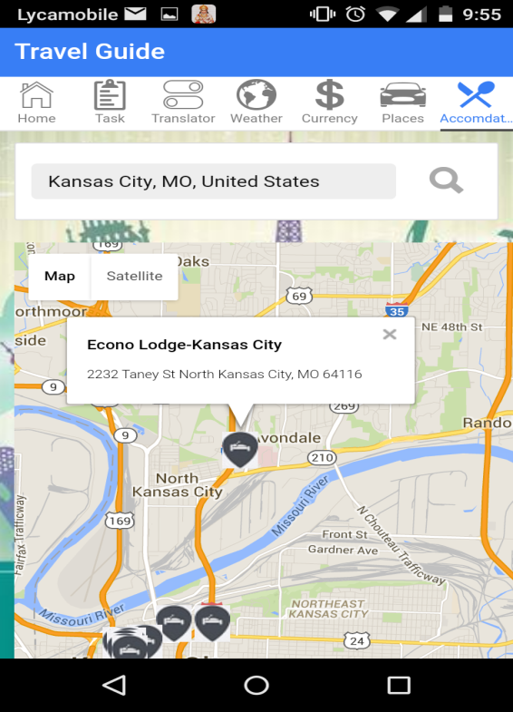

This page shows about the Accommodation feature where we can enter the city of your interest and based on your city , we will get the Accommodation places around that city.

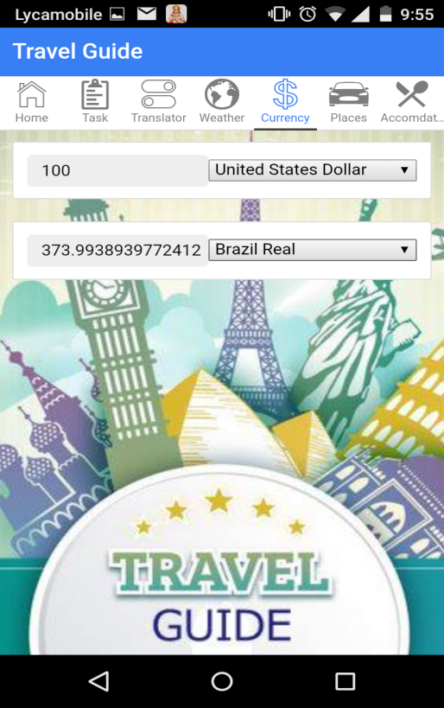

This page shows about the currency Converter feature where user can enter the value of source currency and he can also select source currency and he can also select destination currency in order to retrieve the value of destination currency.

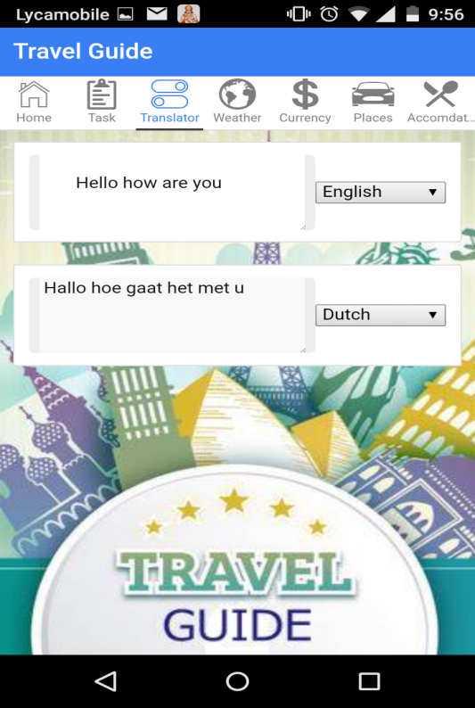

This page shows about the currency Converter feature where user can enter the text of source language and he can also select source language and he can also select destination language in order to retrieve the text of destination language.

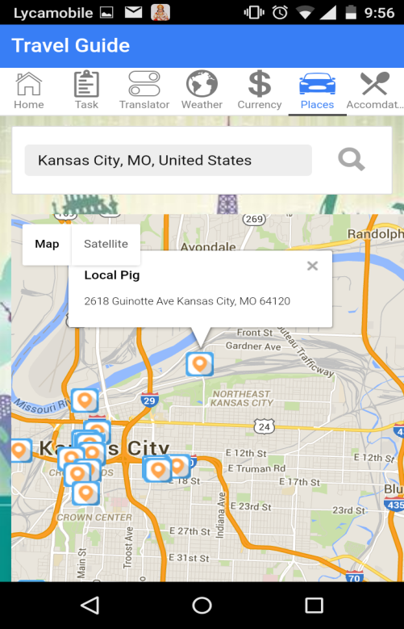

This page shows about the places of Interest feature where we can enter the city of your interest and based on your city , we will get the places around that city.

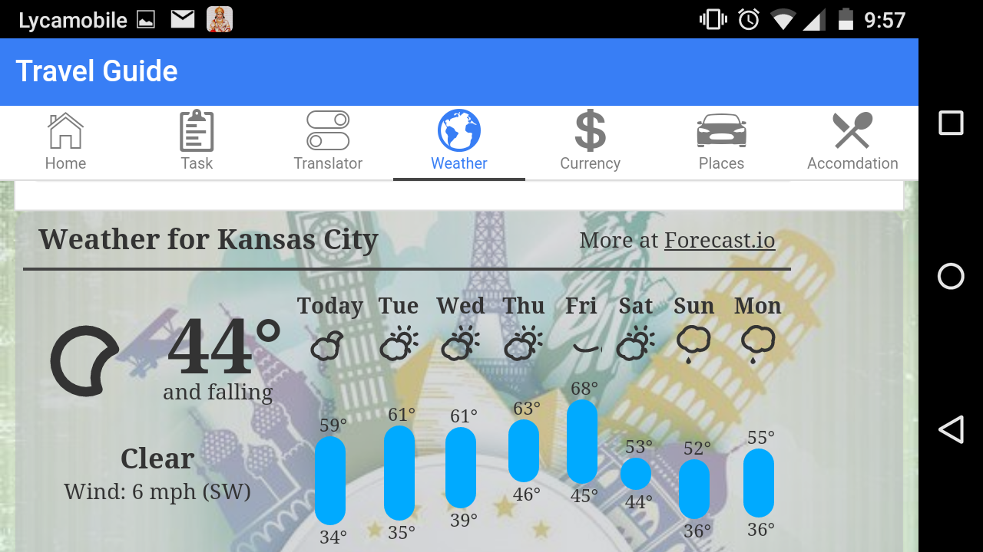

This page shows about the Weather feature where we can enter the city of your interest and based on your city, we will get the weather forecast for the next 7 days.

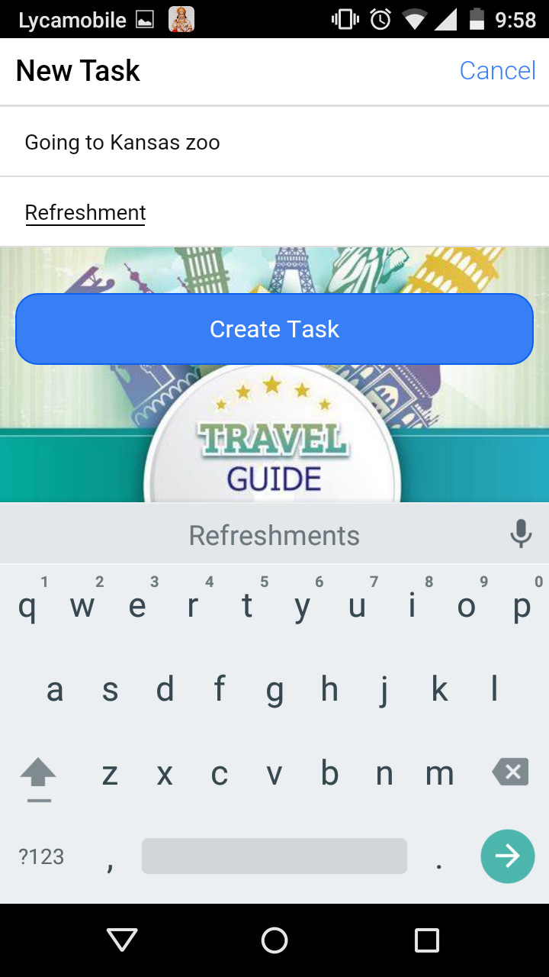

This page shows about the Notifications feature where we can enter the task and description of that task. We can also create notification by setting the day and time the user desires to set reminder.

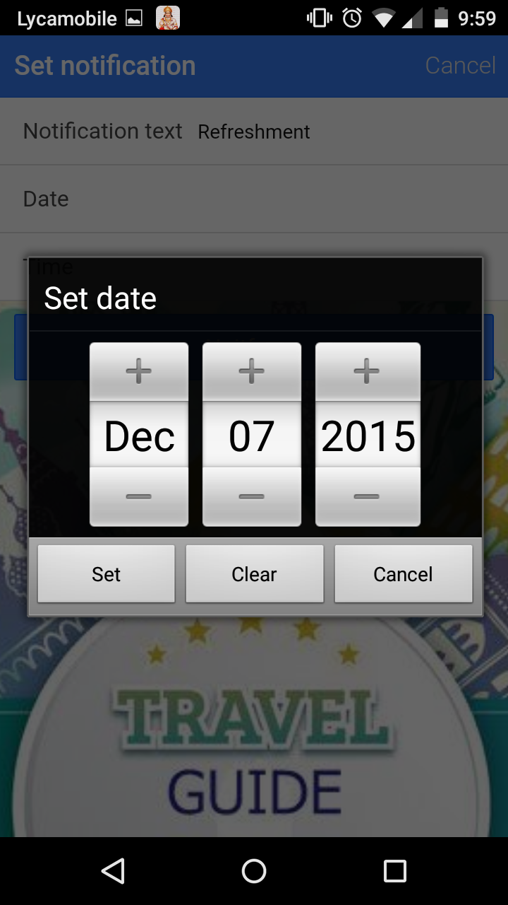

This page shows how to we can set the day and time to which we wanted the notification.

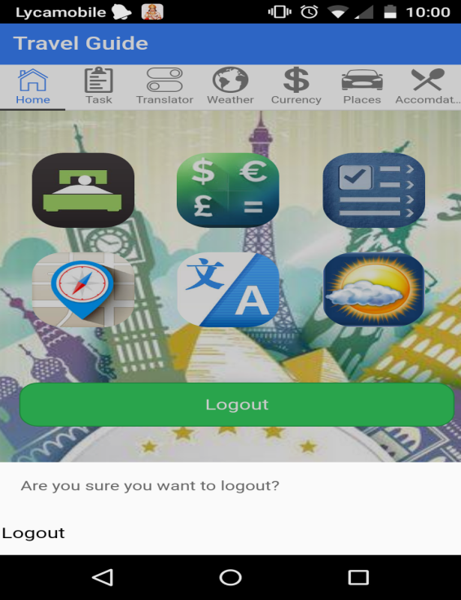

This page shows about we can logout from the app by clicking the logout button.

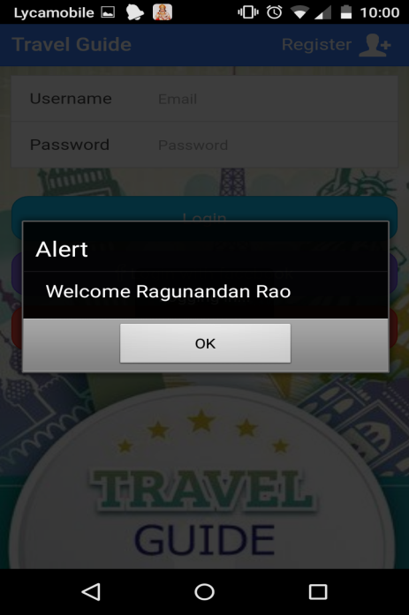

This page shows about how we can login into the App using Facebook by clicking login with Facebook.

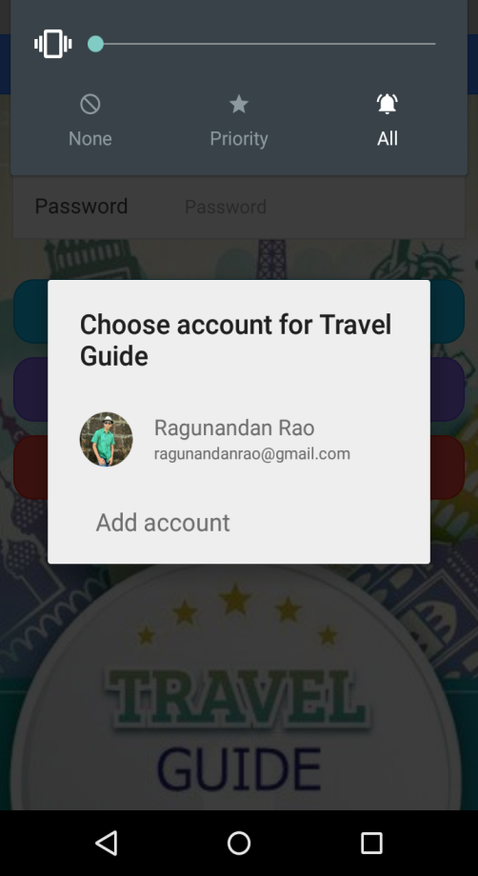

This page shows about how we can login into the App using Google+ by clicking login with Google.

**Bibliography**

[1], [2], [3] and [4] – Content referred from the article “The world’s 50 best travel apps” by the Time out group. URL: <http://www.timeout.com/travel/features/1169/the-worlds-50-best-travel-apps>

**References:**

“Packing list” by Travellerspoint Foundation. URL: <http://www.travellerspoint.com/packing-list.cfm>

Project Management URL: <https://www.visualstudio.com/en-us/products/what-is-visual-studio-online-vs.aspx>

The guide for Google plus login URL: <https://developers.google.com/+/web/signin/>

Facebook sign in option guided by URL: <https://developers.facebook.com/docs/facebook-login>